

**REPUBLIC OF CAMEROON**

**Peace-Work-Fatherland**

**MINISTER OF HIGHER EDUCATION**

**FACULTY OF ENGINEERING**

**AND TECHNOLOGY**

**REPUBLIQUE DU CAMEROON**

**PAIX-Travail-Patrie**

**MINISTRE DE L’ENSEIGNEMENT SUPERIEUR**

**FACULTE DE L’ENGINERIE**

**ET TECHGNOLOGIE**

***\*\*\*\*\*\*\*\*\*\*\*\*\*\*\*\*\*\*\*\*\*\** UNIVERSITY OF BUEA *\*\*\*\*\*\*\*\*\*\*\*\*\*\*\*\*\*\*\*\*\*\*\*\*\****

**DEPARTMENT OF COMPUTER ENGINEERING**

**COURSE: INTERNET PROGRAMMING (J2EE) AND MOBILE PROGRAMMING**

**COURSE CODE: CEF 440**

**TASK 4: SYSTEM MODELLING AND DESIGN OF A MOBILE BASED DISASTER MANAGEMENT SYSTEM**

**PRESENTED BY**

**GROUP 20**

**INSTRUCTOR: DR. VALERY APRIL 2024**

**GROUP MEMBERS**

|  |  |  |
| --- | --- | --- |
| S/N | **Name** | Matricule Number |
| 1 | DUESENBERRY MBIKANG AGBORTAR AKO | FE21A175 |
| 2 | FOTABONG FUALEFAC PUISSANCE | FE21A195 |
| 3 | ABANGMA ARRAH JESUS MCLOUIS | FE21A124 |
| 4 | TABOT JOEL EBANGHA | FE21A308 |
| 5 | EBOMESUMBE NGOLE DANDY BRADLEY | FE21A177 |

Contents

**I – INTRODUCTION** 4

**II - SYSTEM MODELLING OVERVIEW** 5

**2.1. Context Diagram** 5

**2.1.1. Definition:** 5

**2.1.2. Analysis**: 5

**2.1.3. Diagram:** 5

**2.1.4. Diagram Purpose and Importance:** 5

**2.1.5. Diagram Components:** 5

**2.1.6. Actors and Their Roles:** 6

**2.1.7. Functions:** 6

**2.2. Use Case Diagram** 6

**2.2.1. Definition:** 6

**2.2.2. Analysis:** 6

**2.2.3. Diagram:** 7

**2.2.4. Diagram Purpose and Importance:** 7

**2.2.5. Diagram Components:** 7

**2.2.6. Actors and Their Roles:** 7

**2.3. Sequence Diagram** 8

**2.3.1. Description:** 8

**2.3.2. Analysis:** 8

**2.3.3. Diagram:** 8

**2.3.4. Diagram Purpose and Importance:** 9

**2.3.5. Diagram Components:** 9

**2.3.6. Actors and Their Roles:** 9

**2.3.7. Functions:** 9

**2.4. Class Diagram** 9

**2.4.1. Description:** 9

**2.4.2. Analysis:** 9

**2.4.3. Diagram:** 9

**2.4.4. Diagram Purpose and Importance:** 11

**2.4.5. Diagram Components:** 11

**2.4.6. Actors and Their Roles:** 11

**2.4.7. Functions:** 11

**2.5. Deployment Diagram** 11

**2.5.1. Description:** 11

**2.5.2. Analysis:** 11

**2.5.3. Diagram:** 11

**2.5.4. Diagram Purpose and Importance:** 12

**2.5.5. Diagram Components:** 12

**2.5.6. Actors and Their Roles:** 12

**2.5.7. Functions:** 12

**III – CONCLUSION** 13

**IV - REFERENCES** 14

# **I – INTRODUCTION**

This report focuses on the System Modeling and Design phase for the development of a Mobile-Based Disaster Management System intended for efficient response during incidents. It aims to visually represent and design the system structure and interactions using various modeling diagrams, setting a blueprint for subsequent development phases.

# **II - SYSTEM MODELLING OVERVIEW**

System modeling is crucial in software development as it provides a graphical representation of the system, which helps in understanding the system's functionalities and interactions without delving into code. This report will discuss several models including the context diagram, use case diagram, sequence diagram, class diagram, and deployment diagram, each serving to elucidate different aspects of the system architecture and interactions.

## **2.1. Context Diagram**

### **2.1.1. Definition:**

A context diagram is a high-level, simplistic view of an entire system that shows the system as a single process along with its external interactions. It is vital for understanding how the system fits within the larger environment it operates in.

### **2.1.2. Analysis**:

This diagram demonstrates how the system interfaces with users, who receive alerts and submit status updates, and with governmental and response entities, sharing data and commands.

### **2.1.3. Diagram:**

The context diagram for our disaster management system illustrates the system at the center, with lines connecting to external entities like local residents, disaster response teams, and local government.

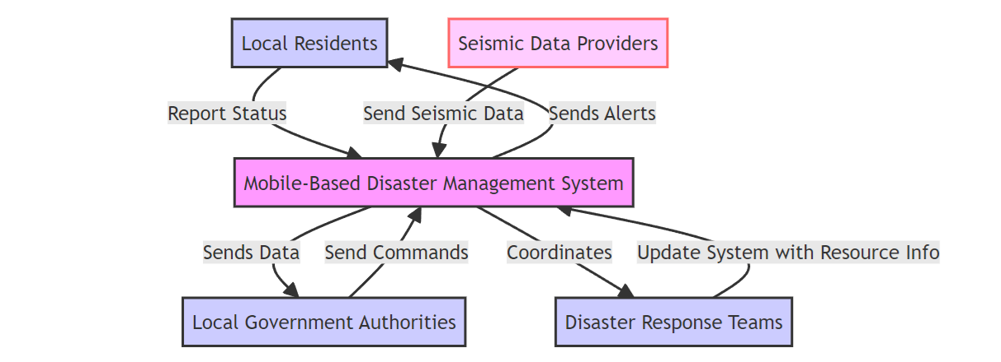

### **2.1.4. Diagram Purpose and Importance:**

Our context diagram serves as a high-level visual representation of the entire system, illustrating the system itself as a single entity and showing how it interacts with external entities. It's essential for providing an immediate understanding of the system’s boundary and its relationship with the outside world—users, external systems, and other stakeholders.

### **2.1.5. Diagram Components:**

* + Mobile-Based Disaster Management System (Central Node): Represents the core system which processes data and interacts with all external entities.
  + Local Residents, Disaster Response Teams, Local Government Authorities, Seismic Data Providers (External Entities): These are the stakeholders and data sources that either provide input to or receive outputs from the system.
  + Data Flows: Arrows indicate the flow of information between the system and external entities:
  + Alerts to residents
  + Status updates from residents to the system
  + Data from seismic providers to the system
  + Commands from local government to the system
  + Resource updates between response teams and the system

### **2.1.6. Actors and Their Roles:**

* Local Residents: Users who will interact with the system to receive alerts and provide updates about their status during a disaster.
* Disaster Response Teams: Groups that coordinate and execute emergency response strategies; they use the system for communication and resource management.
* Local Government Authorities: Government bodies responsible for overseeing disaster management at a policy and operational level. They issue commands and receive aggregated data for decision-making.
* Seismic Data Providers: Entities that provide real-time seismic data, crucial for the system to detect and assess earthquake events.

### **2.1.7. Functions:**

* Local Residents: Receive real-time alerts and safety instructions, and send back their status updates (safe, in need of help, etc.).
* Disaster Response Teams: Use the system to obtain status updates from residents, coordinate resources, and deploy emergency services effectively.
* Local Government Authorities: Use the system to send directives to response teams and the public, and to analyze data for ongoing situation assessment and future planning.
* Seismic Data Providers: Feed seismic data into the system, triggering the system's alert mechanisms when thresholds are exceeded.

## **2.2. Use Case Diagram**

### **2.2.1. Definition:**

Use case diagrams are a set of actions, services, and functions that the system needs to perform in interaction with users or other systems. This diagram is crucial for identifying and organizing system requirements.

### **2.2.2. Analysis:**

Critical use cases for the disaster management system include alert notification to users, user status updates to response teams, and emergency information dissemination, all pivotal for effective disaster management.

### **2.2.3. Diagram:**

The use case diagram includes actors such as residents and response teams, and use cases like receive alerts, report status, and access emergency info.

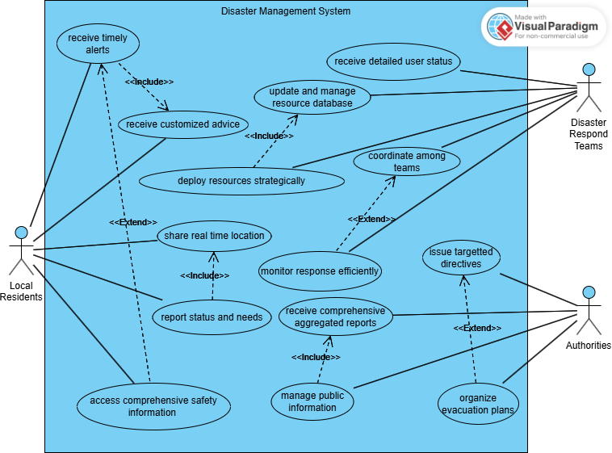

### **2.2.4. Diagram Purpose and Importance:**

The use case diagram helps to visualize the functionality of the system from the user's perspective, showing different ways that users (actors) can interact with the system. It's crucial for identifying and structuring the requirements that the system must fulfill.

### **2.2.5. Diagram Components:**

* Actors (Local Residents, Disaster Response Teams, Local Government(Authorities)): Represent different users who interact with the system.
* Use Cases (Receive Alerts, Share Location, etc.): These are specific functionalities that the system provides, detailing the actions actors can perform with the system.

### **2.2.6. Actors and Their Roles:**

* Residents: Interact with the system to receive information and provide personal status updates during disasters.
* Response Teams: Manage and coordinate emergency responses using the system to access real-time data from residents and other sources.
* Government Officials: Use the system to monitor disaster management efforts and communicate with both the public and response teams.

## **2.3. Sequence Diagram**

### **2.3.1. Description:**

Sequence diagrams map out the sequence of events that occur between objects as they interact over time within a scenario. They are instrumental in visualizing the temporal order of interactions.

### **2.3.2. Analysis:**

This diagram highlights how quickly and efficiently the system must operate to notify users of an impending disaster, critical for minimizing response times and maximizing safety.

### **2.3.3. Diagram:**

A sequence diagram for the "Disaster Alert Issuance" scenario shows interactions starting from the seismic activity detection, system processing, and alert dispatch to user devices.

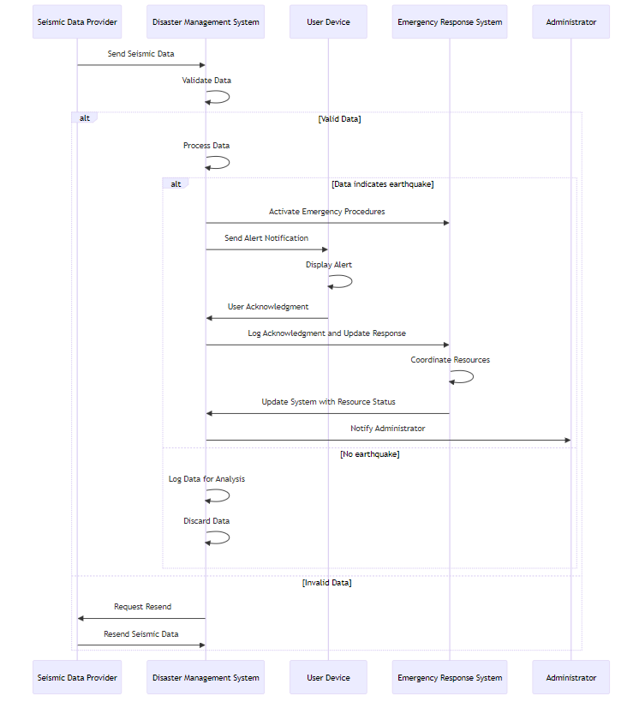

### **2.3.4. Diagram Purpose and Importance:**

Sequence diagrams detail the interactions between system components and actors over time, focusing on the order of message flows and processes. This diagram is particularly useful for understanding how operations are carried out within the system in response to specific events, such as the detection of an earthquake.

### **2.3.5. Diagram Components:**

* Participants (Seismic Data Provider, Disaster Management System, User Device): Entities involved in the process.
* Interactions: Steps like sending seismic data, processing data, and sending alerts show the temporal sequence of operations from data reception to user notification.

### **2.3.6. Actors and Their Roles:**

* Seismic Data Provider: Supplies initial data that triggers the system's alert processes.
* Disaster Management System: Processes seismic data, determines the necessity of alerts, and manages data flow to other components.
* User Device: Receives alerts and displays them to the user; sends back user acknowledgments or requests for help.

### **2.3.7. Functions:**

* Seismic Data Provider: Sends seismic activity data to the system.
* Disaster Management System: Processes incoming data, decides on alert issuance, and disseminates information to user devices.
* User Device: Acts as the interface for the user, receiving alerts, displaying information, and allowing users to interact with the system.

## **2.4. Class Diagram**

### **2.4.1. Description:**

Class diagrams represent the static structure of a system by showing the system's classes, their attributes, and operations, along with the relationships among objects.

### **2.4.2. Analysis:**

This diagram is essential for developers to understand how different entities within the system are structured and interact, such as how alerts are generated and handled or how users interact with the system.

### **2.4.3. Diagram:**

The class diagram would include classes such as User, Alert, Emergency Response, each with their respective attributes and methods.

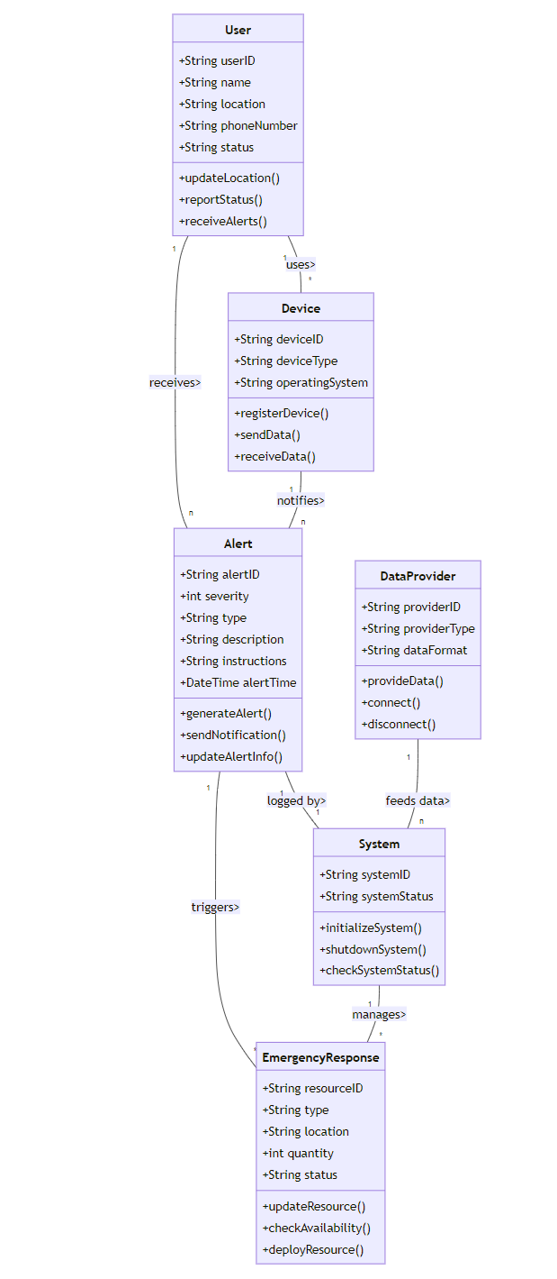

### **2.4.4. Diagram Purpose and Importance:**

Class diagrams provide a static view of the system and its structure, showing the system's classes, their attributes, operations, and relationships. This is crucial for developers to understand the data and behavior organization within the system, facilitating coding and implementation.

### **2.4.5. Diagram Components:**

* Classes (User, Alert, Emergency Response): These are blueprints defining objects in the system, detailing their properties (attributes) and functionalities (methods).
* Relationships: Lines connecting classes indicate interactions and dependencies, like users receiving alerts or alerts triggering emergency responses.

### **2.4.6. Actors and Their Roles:**

* User Class: Represents the end-users of the system, storing information such as location and status.
* Alert Class: Manages the creation and distribution of alert notifications to users.
* Emergency Response Class: Manages resources and responses during emergencies.

### **2.4.7. Functions:**

* User Class: Updates and reports user location and status.
* Alert Class: Generates alerts based on data and criteria, sends notifications to users.
* Emergency Response Class: Updates resources available and checks their availability for efficient deployment.

## **2.5. Deployment Diagram**

### **2.5.1. Description:**

Deployment diagrams are used to show the physical arrangement of software on hardware components. This is crucial for understanding how software and hardware integrate in real-world operation.

### **2.5.2. Analysis:**

This illustrates the deployment strategy to ensure that the system is scalable, secure, and robust, capable of handling high loads during peak disaster times.

### **2.5.3. Diagram:**

The deployment diagram shows the distribution of the mobile application across user devices, connected through secure networks to centralized servers that manage data and interactions.

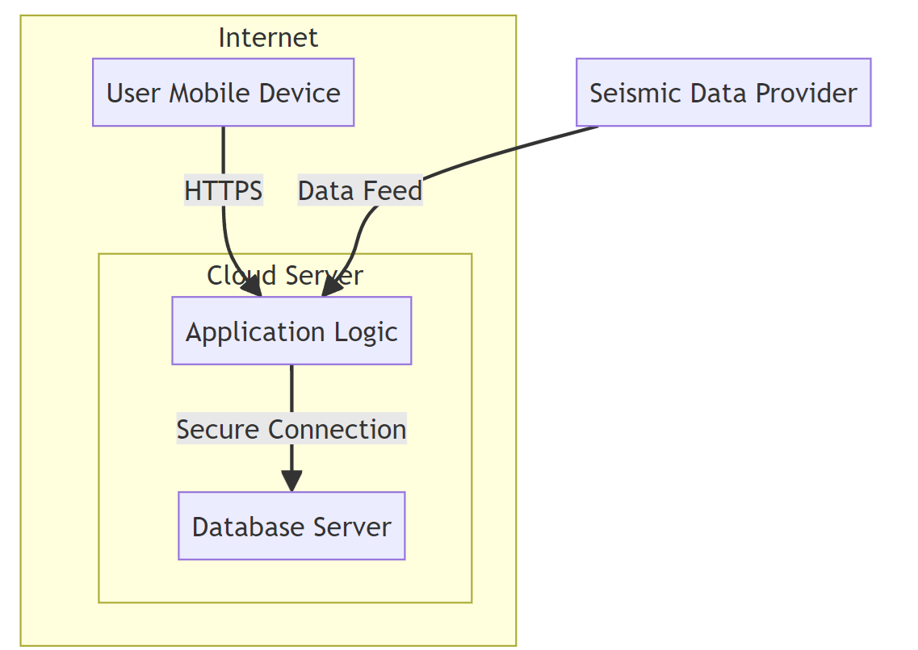

### **2.5.4. Diagram Purpose and Importance:**

Deployment diagrams illustrate how a system's software is deployed across different hardware components, showing the physical configuration and how components communicate. This diagram is vital for system administrators and developers to plan and manage the infrastructure needed for the system's operation.

### **2.5.5. Diagram Components:**

* Nodes (User Mobile Device, Cloud Server, Application Logic, Database Server): Represent hardware or virtualized hardware where system components are deployed.
* Connections (HTTPS, Secure Connection): Show how data flows securely between nodes, ensuring data integrity and security.

### **2.5.6. Actors and Their Roles:**

* User Mobile Device: Where the application is installed and used by local residents.
* Cloud Server (Application Logic, Database Server): Hosts the application logic and the database storing all system data, ensuring that data is processed and stored centrally for access by all other system components.

### **2.5.7. Functions:**

* User Mobile Device: Executes the front-end application, interacts with the user, and communicates with the cloud server.
* Cloud Server: Handles all major processing tasks, data storage, and communication between the user devices and the system’s backend.

These detailed explanations for each diagram type provide clarity on the roles and functions of various actors within the Mobile-Based Disaster Management System. This approach not only enriches understanding but also aids in the precise development and integration of system components.

# **III – CONCLUSION**

The system modeling covered in this report provides a comprehensive framework for the mobile-based disaster management system. These models facilitate a deeper understanding of the system’s architecture and are instrumental in guiding the next phases, including UI design and database implementation. The clarity provided by these models will aid in efficient and effective development, ensuring that the final system is robust, user-friendly, and capable of handling the demands of disaster management.

# **IV - REFERENCES**

* Task 1 report
* Task 2 report
* Task 3 report
* <https://www.researchgate.net/figure/Overview-of-models-used-in-disaster-risk-assessment-and-emergency-planning_tbl1_248880426>
* <https://www.ncbi.nlm.nih.gov/pmc/articles/PMC6014072/>
* <https://sites.tufts.edu/jha/files/2011/04/a193.pdf>
* <https://www.sciencedirect.com/science/article/abs/pii/S037872061300030X>
* <https://terrorvictimresponse.ca/wp-content/uploads/2013/10/model.pdf>
* <https://www.igi-global.com/chapter/an-overview-of-disaster-and-emergency-management-systems-models/207566>